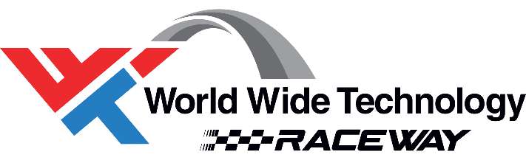

2022 Campground Host Staff – World Wide Technology Raceway

WWT Raceway is putting out an open call for campground hosts and hostesses for our upcoming 2022 special event season.
Campground hosts are public relations liaisons for WWT Raceway as they are often the first faces to greet track visitors. Hosts welcome campers, write camping permits, acquaint campers with track facilities and regulations, answer questions on local amenities and attractions, and help visitors plan their days at the track. Campground hosts stay in their own RV, motor home or trailer at a special camp site.
Above all else, the quality all campground hosts possess is enthusiasm for working with the public.
Schedule:
INDYCAR Weekend Positions Available: Campground Hosts must be able to be on-site from Monday, August 15, 2022 until Sunday, August 21, 2022. Roaming Hosts must be available Thursday-Sunday of race week.
- Host move-in Monday, August 15, 2022 - 9 a.m.
- Host Orientation Training (Welcome Dinner) – Monday, August 15, 2022 – 5 p.m.
- Set-Up, Layout – Tuesday, August 16, 2022 – 9 a.m.
- Host move-out – Sunday, August 21, 2022 – 5 p.m.
NHRA Weekend Positions Available: Campground Hosts must be able to be on-site from Monday, September 26, 2022 until Sunday, October 3, 2022. Roaming Hosts must be available Thursday-Sunday of race week.
- Host move-in Monday, September 26, 2022 - 9 a.m.
- Host Orientation Training (Welcome Dinner) – Monday, September 26, 2022 – 5 p.m.
- Set-Up, Layout – Tuesday, September 27, 2022 – 9 a.m.
- Host move-out – Sunday, October 3, 2022 – 9 p.m.

